Log into SHIPPING EASY

1. CLICK REPORTS
2. DATE RANGE
3. CUSTOM REPORTS DROP DOWN
4. CREATE REPORT

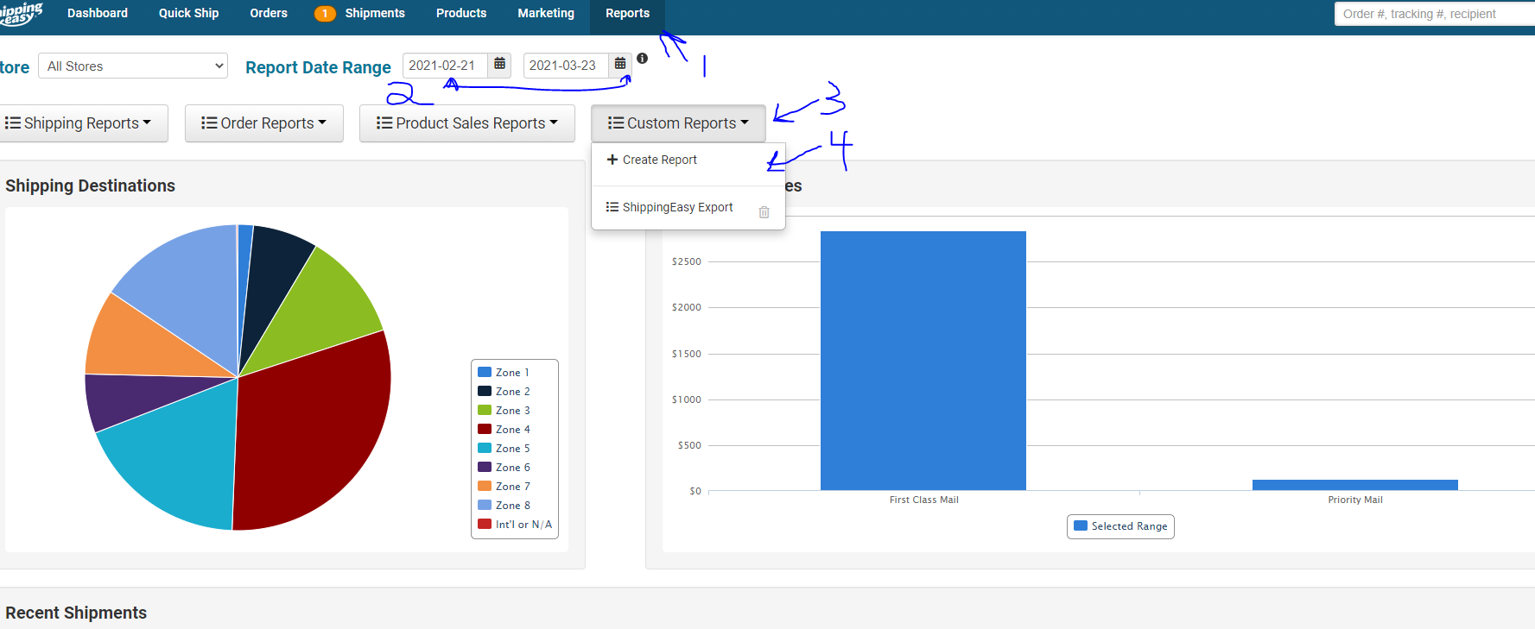

1. EXPORT
2. NOW
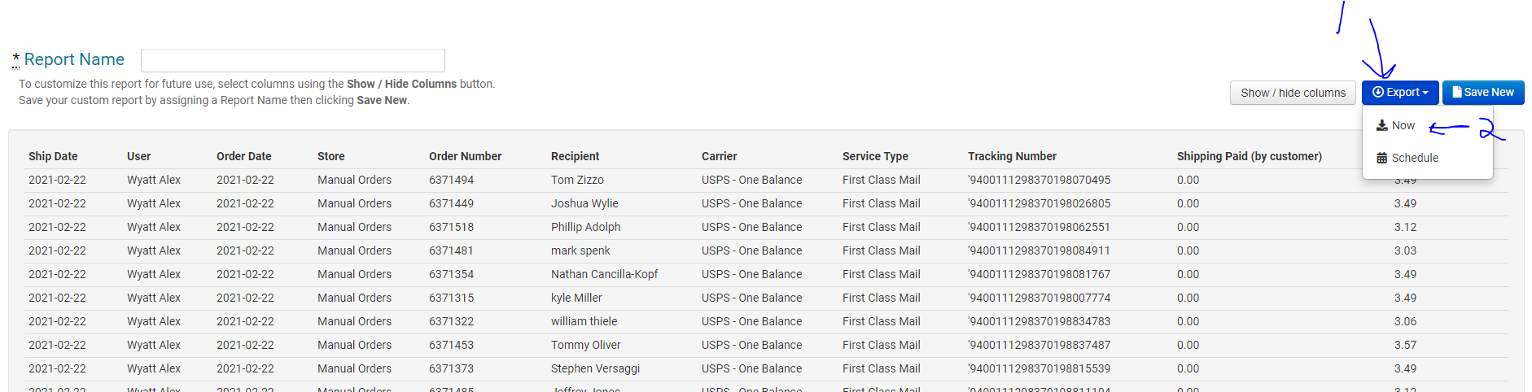

1. REFRESH
2. SHOULD SAY “READY” IN GREEN
3. DOWNLOAD
4. OPEN AND SAVE

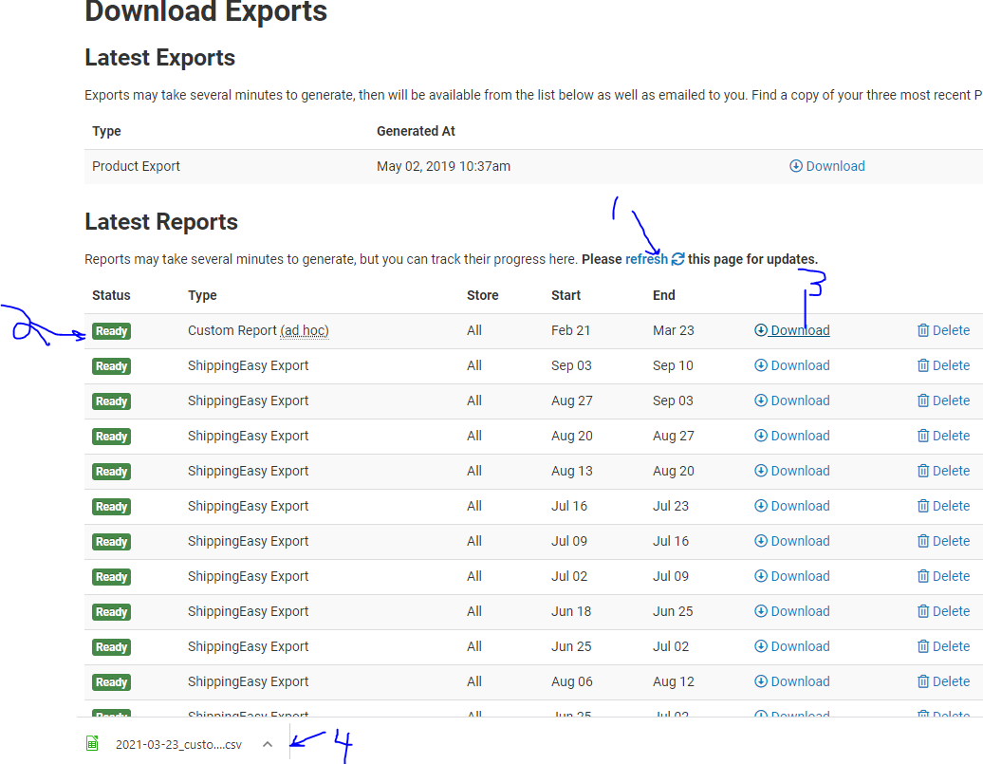

1. “COMPARE SHIPPING TO SHIPPINGEASY”

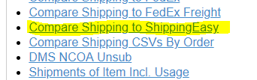

1. CHOOSE FILE
2. SELECT SAVED FILE
3. CLICK AND RUN “CREATE REPORT”

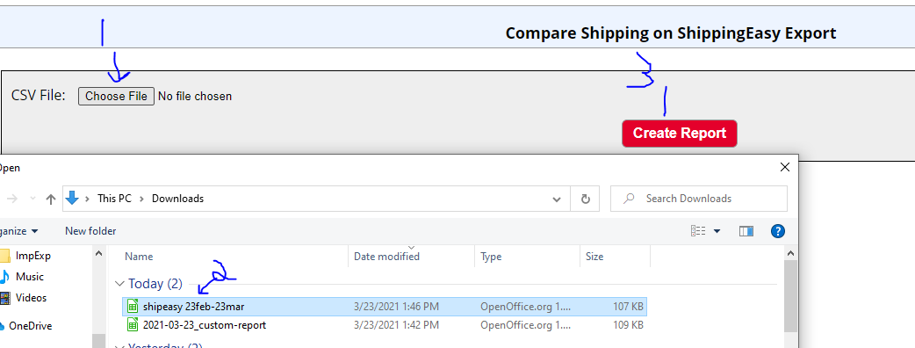

This will create the Report Comparison open up and sort accordingly.

